**Subprograms**

The purpose of subprograms is to perform specific tasks and to allow code to be run at any time during the program.

**What are the Advantages?**

You can write a block of code and it can be used again and again at various times during the program.

It makes the program simpler to understand as the code is grouped together into chunks.

Def main():

User_name,User_age =

= get_data()

Message(User_name,User_age)

# Defines a subprogram called main () which obtains the two variables from get_data() subprogram. These must be labelled in the same order as they were defined in the tuple. It then calls the message () subprogram to run with the two variables.

Main ()

# Runs the program above

Def get_data():

Username = Input (“Enter your Name”)

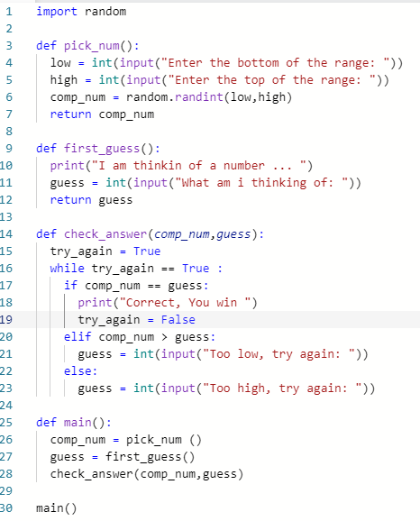

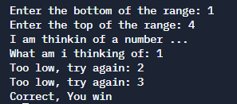` ``

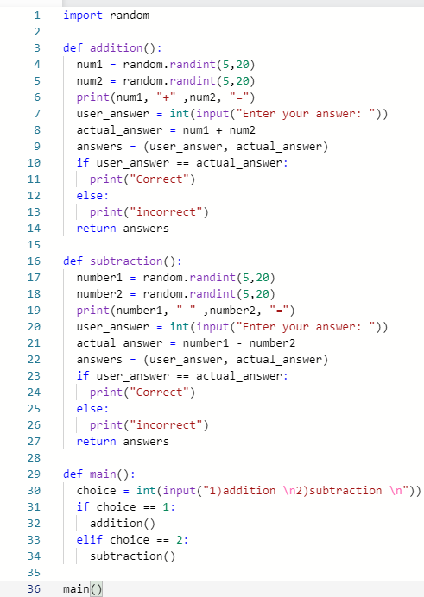

**Addition:**

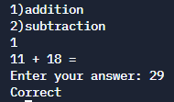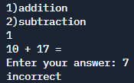

**Subtraction:**

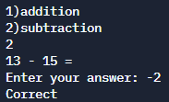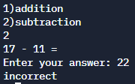

**Error:**

